Multiple Linear Regression Results

**Trial #1**

Features Tested: Danceability, Energy, Tempo, Loudness

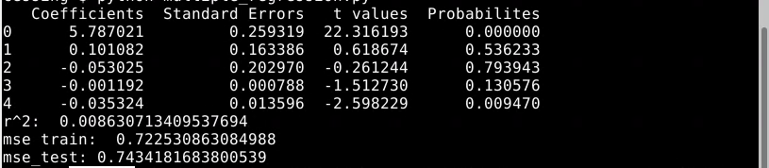

**Trial #2**

Features Tested: Danceability, Tempo, Liveness, Valence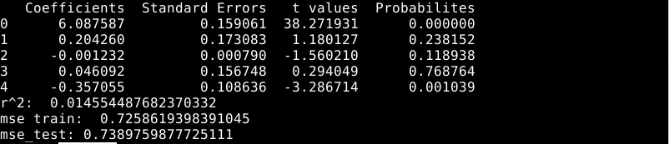

**Trial #3**

Features Tested: Danceability, Valence, Acousticeness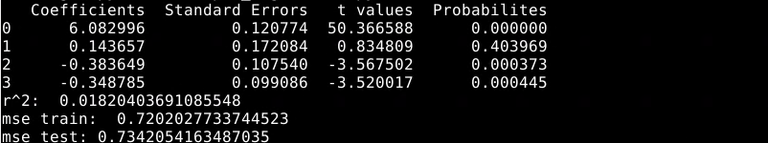

**Trial #4**

Features Tested: Danceability, Valence, Acousticeness, Tempo

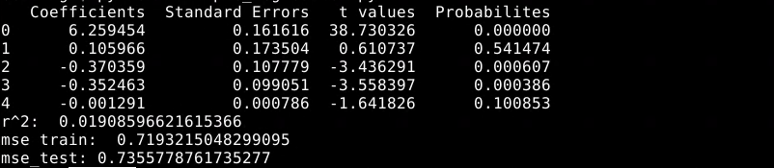

**Trial #5**

Features Tested: Danceability, Valence, Speechiness, Tempo

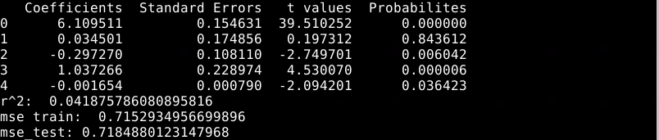

Trial #6

Features Tested: Valence, Speechiness, Tempo

